**Nuclear Magnetic Resonance**

Ronaldo Rodriguez, Adreas Kooi  
 Univeristy of California, Santa Cruz Physics Department

Febuary 27, 2019

**INTRODUCTION**

It is known that all nucleons have some intrinsic angular momentum so termed as spin. This spin angular momentum results in a magnetic moment given by $μ_{N}=γS$ Eq. 1, where  is the gyromagnetic ratio of a nucleon and **S** is the spin angular momentum vector. If a magnetic field is applied in the z-direction, the magnetic moment experiences a potential given by

$U= -γℏI_{z}B$ Eq. 2. Iz corresponds to the different values of spin angular momentum allowed by quantum mechanics. For a spin ½ nucleus the allowed values are ± ½. This means that there are only two possible values for the potential, U. they are separated by $∆U= γℏB Eq. 3.1$ or in terms of a frequency $∆U= ℏω_{0} Eq. 3.2$. In a system N1 and N2 are the number of spins in the high and low energy configurations respectively. This frequency is referred to as the magnetic resonant frequency and we can manipulate our system using radio frequency (RF) radiation to manipulate the system.

In the late 1930’s Isidor I. Rabi first discovered this effect, for which he was awarded the 1944 Nobel Prize in physics [1]. Since its discovery nuclear magnetic resonance (NMR) has been utilized for purposes such as medical diagnostic imaging or organic chemical structure analysis. In our experiment we use a pulsed NMR spectrometer to study the behavior of nuclei in mineral oil.

**THEORY**

If the equilibrium magnetization is given by M0, the rate of change in the Z magnetization is given by $\frac{dM_{z}}{dt}=\frac{M_{0}-M_{z} }{T_{1}}$ Eq.4. Solving this differential equation gives us the magnetization in the z-direction as a function of time, $M_{z}\left(t\right)= M_{0}(1-e^{-\frac{t}{T_{1}}})$ Eq.5 T1 represents a quantity called the spin-lattice relaxation time and is a measure of the time the spins take to adjust to a new magnetic environment. If we rotate the spins such that they lie in the x-y plane we expect magnetization in the x-y plane to decay as $M_{xy}(t)=M(t=0)e^{-\frac{t}{T_{2}^{*} }}$ Eq. 6. The constant T*2 represent the decay time of the spins taking into account both the true spin relaxation time and spin dephasing effects due to inhomogeneities in the applied field. Typically the inhomogeneities in the field dominate other terms so we can approximate T*2, otherwise known as the Free Induction Decay (FID) as $\frac{1}{T_{FID}}≈γ∆B$ Eq. 7.

**METHODS**

To analyze our mineral oil sample, we employ the use of the TeachSpin PS1-A pulsed NMR spectrometer. We use a permanent neodymium magnet as our external field source. The spectrometer is comprised of an RF pulse synthesizer which allows for the generation of precise RF pulsed used to study the sample, a receiver that allows us to observe the NMR signal, and a pulse programmer that allows us to employ various types of pulse sequences to measure T1 T2 and the FID time. To verify our resonance condition, we employ a beat mixer that uses both input and output signals from the sample chamber to produce a “beat” pattern. We achieve our resonance condition when we observer no beat pattern on the mixer output. All signals are measured using a digital oscilloscope. While we do not measure the magnetization directly we know that the x-y magnetization is directly proportional to the receiver output voltage

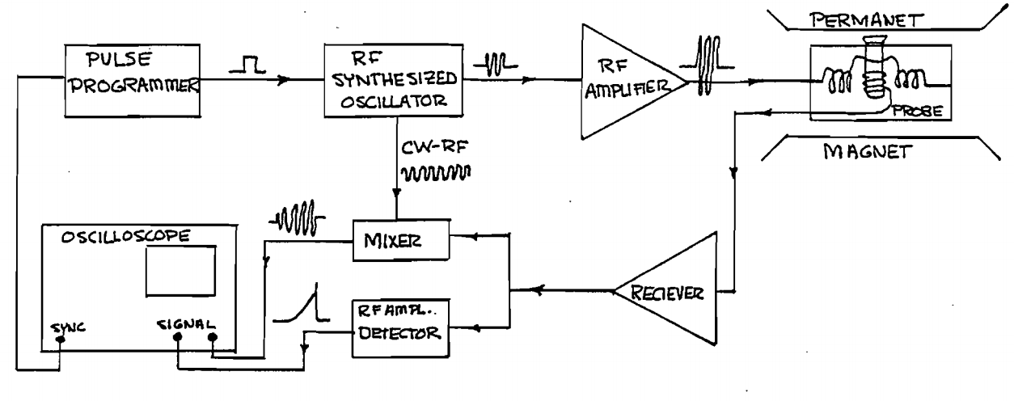

Figure 1:

Schematic of our spectrometer, input signals from our oscillator manipulate the spins in our sample. We measure the x-y magnetization using the output signal from the amplified receiver signal.

To produce the 90 and 180 degree pulses that will rotate the spins in the respective orientations, we measure the x-y magnetization as a function of pulse width. 90 degree pulses result in a maximum in the magnetization, correspondingly the 180 degree pulse is exactly double the width of the 90 degree pulse. We measure the width of the 90 pulse to be t = 6.70 ± 0.01 μs and our 180 degree pulse to be t = 13.4 ± 0.01 μs. To measure the FID time, we apply exactly one 90 degree pulse and measure two points on the decay curve to calculate the time constant using the model provided by Eq.6. To measure T1 we employed a 2-pulse sequence. The first pulse is a 180 degree to rotate the spins to an unstable configuration we wait some time τ, during this time the spins are allowed to slowly return to equilibrium. We then apply a 90 degree pulse rotating all spins still in the z-direction to the transverse x-y plane. Plotting the magnetization as a function of the delay time we can calculate T1. For measurements of T2 we apply three different pulse sequences, Hahn echo, Carr-Purcell (CP) and, Meiboom-Gill (MG). The Hahn echo pulse sequence uses a two pulse sequence, a 90 degree pulse to rotate the spins then a 180 degree pulse to allow the spins to rephrase producing a so-called echo. Both the CP and MG use more than two pulses in their train. The Carr-Purcell sequence uses a similar sequence to the Hahn pulse sequence, where they differ is in the CP sequence there are multiple 180 degree pulses following the initial 90 degree pulse. Finally, the Meiboom-Gill sequence is identical to the Carr-Purcell sequence albeit with a 90 phase shift in the 180 degree pulse following the initial 90 degree pulse. For all three sequences we plot the amplitude of the echo as a function of the time between the two pulses and fit the data to Eq.6 solving for T2. All plots are made using a python least squares fitting routine.

**RESULTS**

We found that we achieved our resonance condition corresponding to a zero beat mixer output at a pulse frequency of ƒ0= 15.42248 +0.046 -0.052 MHz. We qualitatively estimate our error by tuning the pulse frequency until we observe a beat pattern on the mixer output.

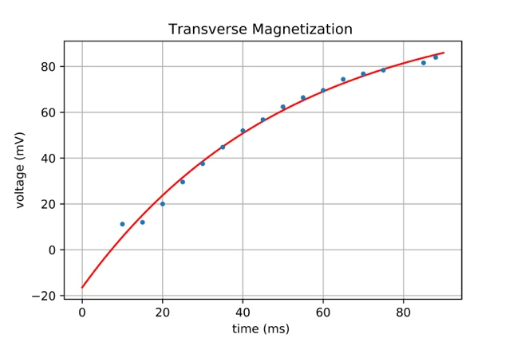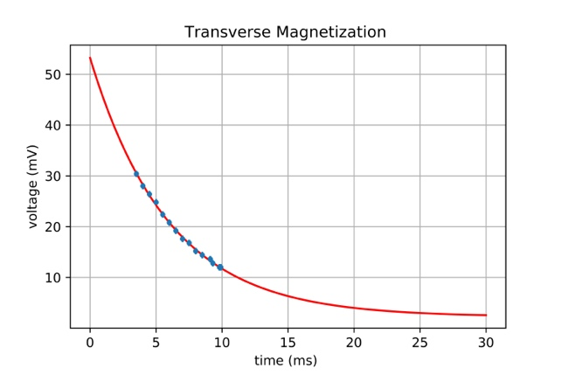To calculate T1 we hypothesized that the amplitude of our receiver output would follow

$A= A_{0}\left|2e^{\frac{-t}{T_{1}}}-1\right|.$ Results from our fit resulted in a value of T1= 17 ms, however our data deviated up to 30% from our fit. In an attempt we cut the data in half at the zero-crossing point and either side to its own decaying exponential, $A=A_{0}e^{\frac{-t}{T_{1}}}$. We found that each half of the data had drastically different decay characteristics. From our analysis we calculate that T1 must lie in a range from 7ms -50 ms, likely lying somewhere near 17 ms

Figure 2:

Left : We calculate our value of T1 from our fit to be 7ms our data fit with a reduced  of 14.26

Right: we calculate our value of T1 to be 50 ms, our data fit with a reduced  of 0.18

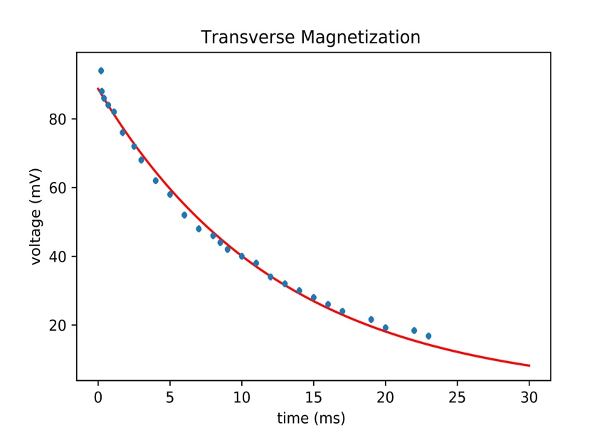From our data, we calculate the value of our FID time to be 10.22±0.438 μs. Using the Hahn pulse sequence we calculate the value of T2 to be 13.28 ± 0.68 ms. Using γ= 2.675 x 104 1/sec*gauss and Eq.7, we estimate the inhomogeneity of the magnetic field to be 3.65 ± 0.15 gauss/radian. We calculated our error using the bump up/down method using our error bars on the FID time for the bump steps.

Figure 2: We fit our data using to Eq.6 we find that the data at most deviated by 7% from the fitting function. Vertical error bars are 1.04 mV in height

Using the Carr-Purcell method with a delay time set to 0.4 ms between each 180 degree pulse, we calculate our value of T2 from our fit to be 8.0 ± 1.6 ms. We calculate the error on this measurement from maximum deviance of our data from the fit which was 20%. We note that the Carr-Purcell value of T2 is over half the value as calculated using the Hahn sequence.

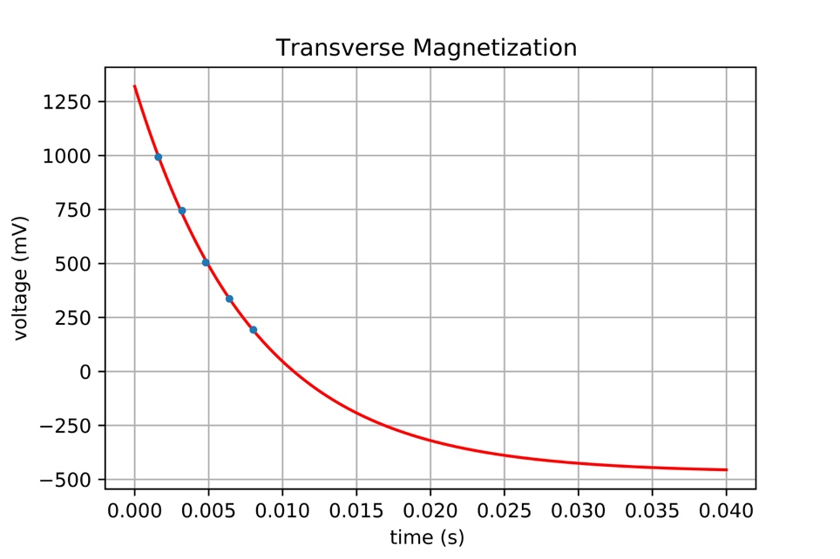

Figure 4: Amplitude as function of time using a Carr-Purcell pulse sequence. We were only able to clearly resolve a few echo signals, the rest fell below the noise level of 18.4 mV.

Vertical error bars are 0.18 in height and were calculated by measuring the fluctuations in the height of the first echo signal after averaging the signal 128 times.

Utilizing the Meiboom-Gill pulse sequence, with a delay time of 0.25ms per 180 degree pulse, resulted in a T2 value of 16.8 ± 0.6 ms as calculated using a least squares regression.

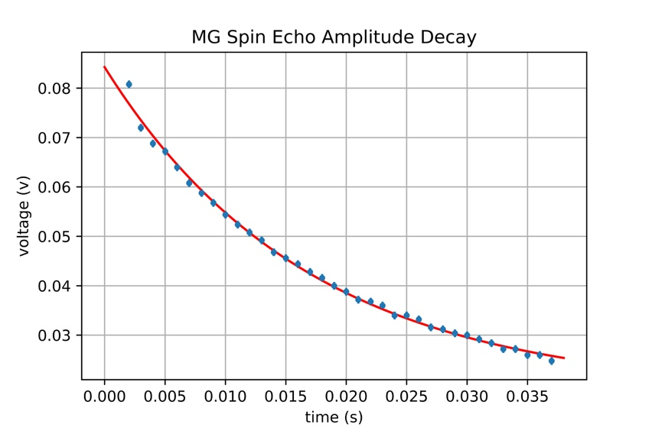

Figure 5: Amplitude as a function of time using the Meiboom-Gill pulse sequence. Our data fit with a reduced  of 1.37. Vertical error bars are 0.022 mV in height and were calculated in a similar manner to those of the Carr-Purcell data.